Step-by-Step Process for Documentation
You can use this directly in your README under a section like Procedure or Steps Performed.

Step 1 — Sign in to Jenkins
- Open the Jenkins URL in your browser.
- Enter the username: admin
- Enter the password as provided.
- Click Sign in to access the Jenkins Dashboard.
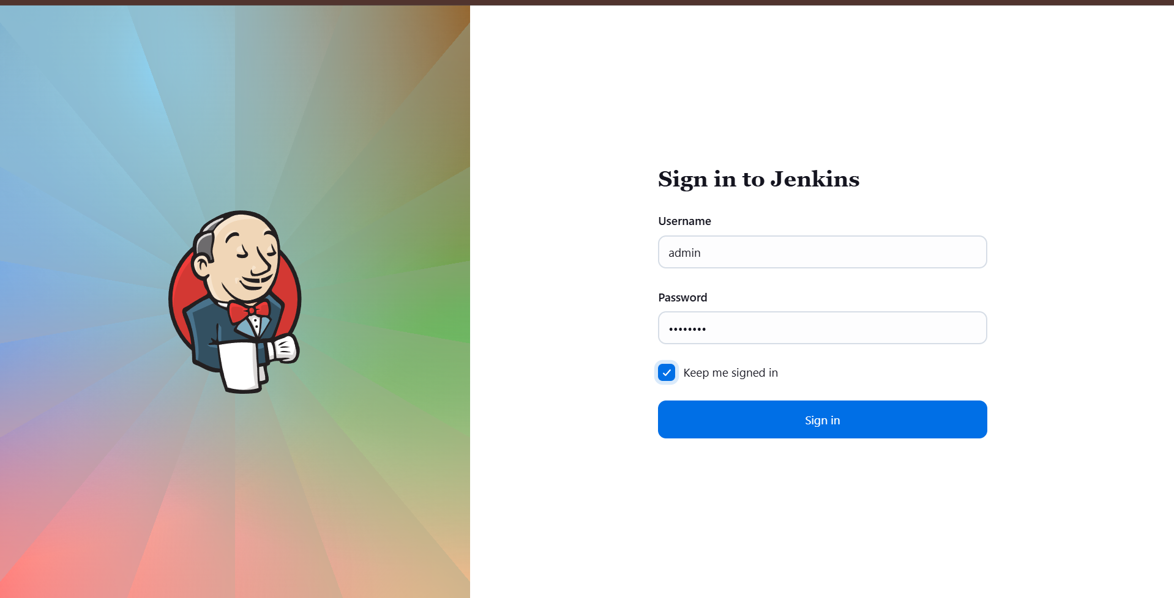

Step 2 — Create a New Jenkins Job
- From the Jenkins Dashboard, click on New Item.
- Enter the job name: xfusion-test-job.
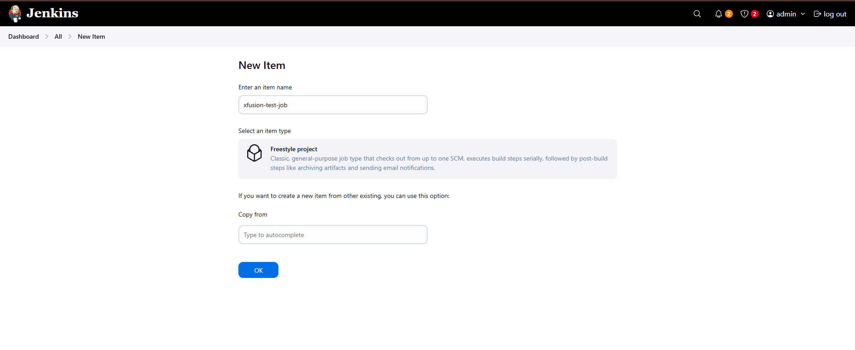
- Select Freestyle project.
- Click OK to create the job.

Step 3 — Configure Build Step (Execute Shell)
- Go to the Configure section of the job.
- Scroll to Build Steps.
- Click Add build step → Execute shell.
- In the command box, add:
- echo "hello world!!"
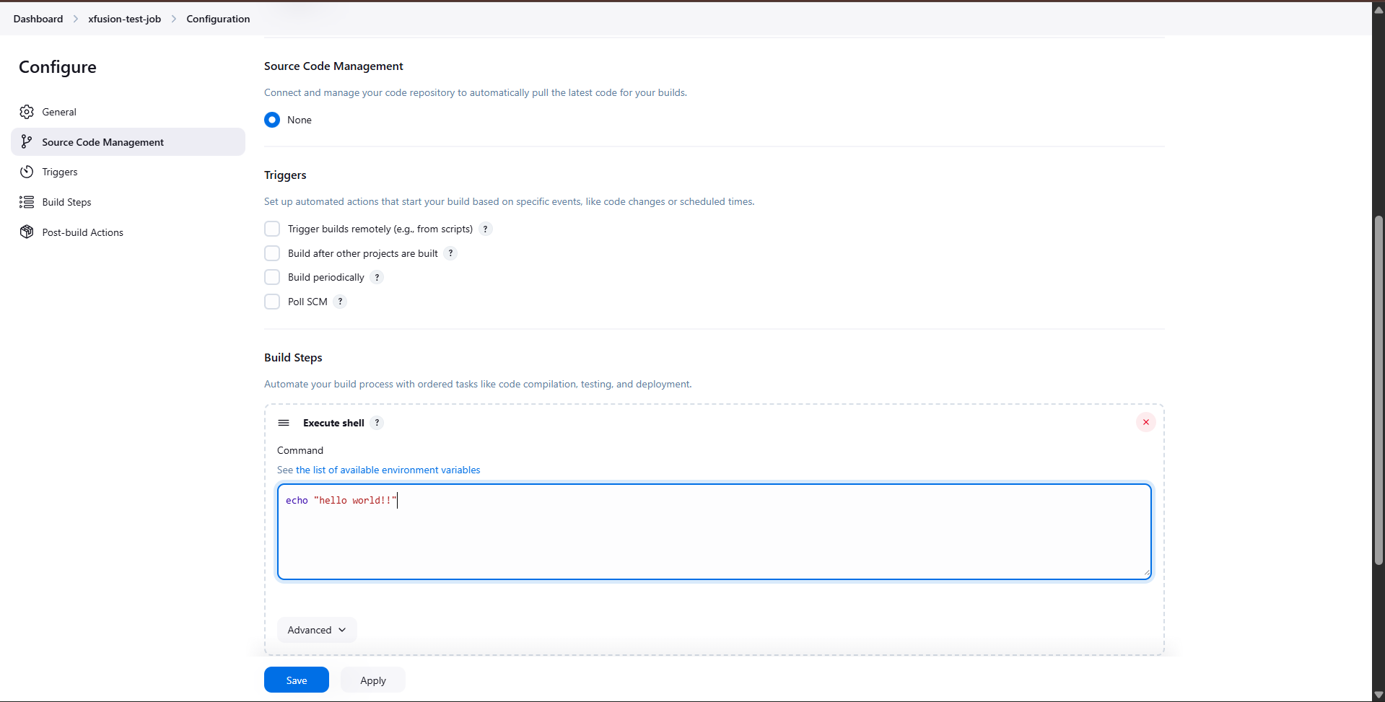
- Click Apply and then Save.

Step 4 — Schedule the Job (Build Periodically)
- In the same job configuration page, go to Build Triggers.
- Check Build periodically.
- In the Schedule box, enter:
- * * * * *
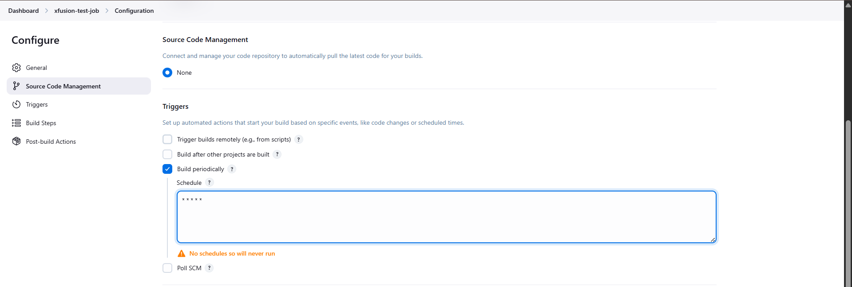
- Click Apply and Save.

Step 5 — Create a New Global View
- From the Jenkins Dashboard, click on the + (New View) button.
- Enter the view name: xfusion-crons.
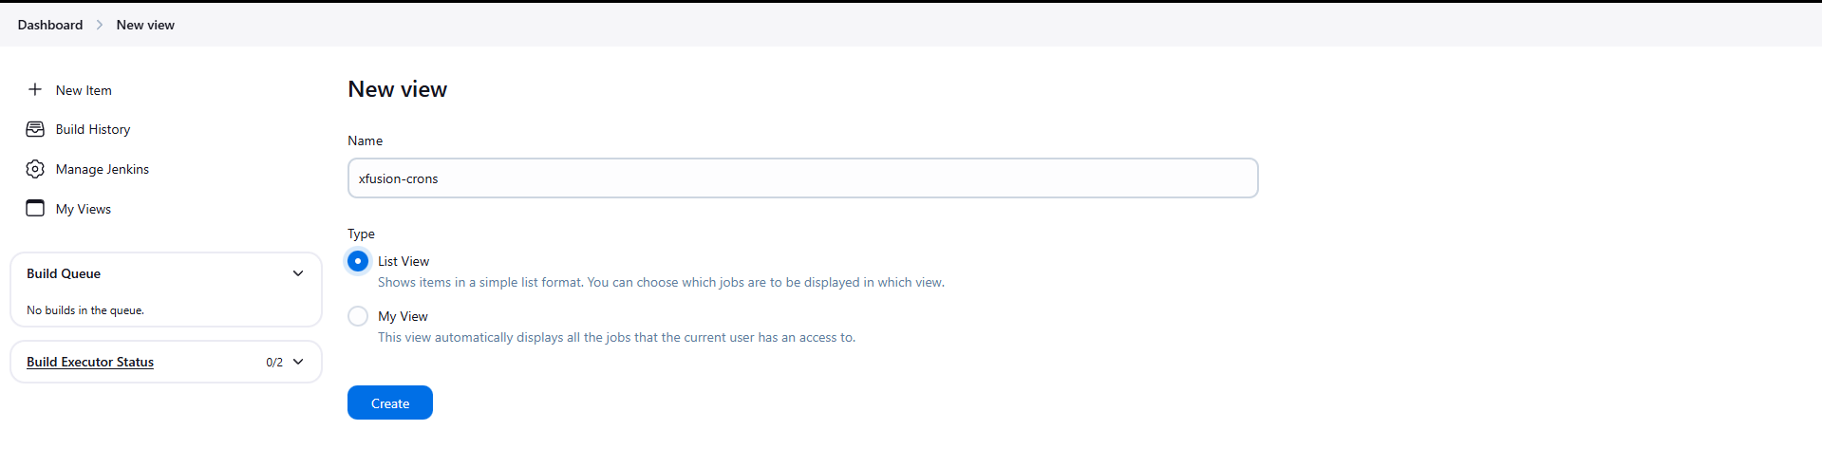
- Select List View.
- Click Create.

Step 6 — Add Jobs to the View
- In the xfusion-crons view, click Edit View.
- Under Jobs, select:
  - xfusion-cron-job (if already present)
  - xfusion-test-job
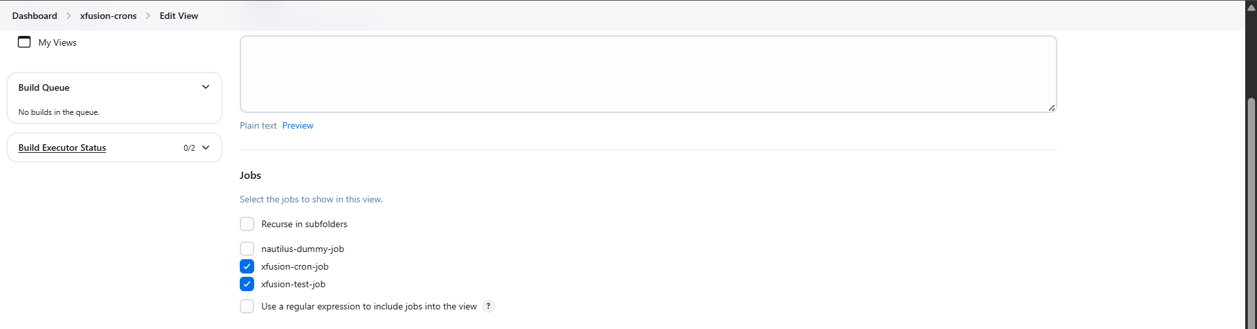
- Click Apply and Save.

Step 7 — Verify the View
- Go to the xfusion-crons view.
- Confirm that both jobs are visible in the list.
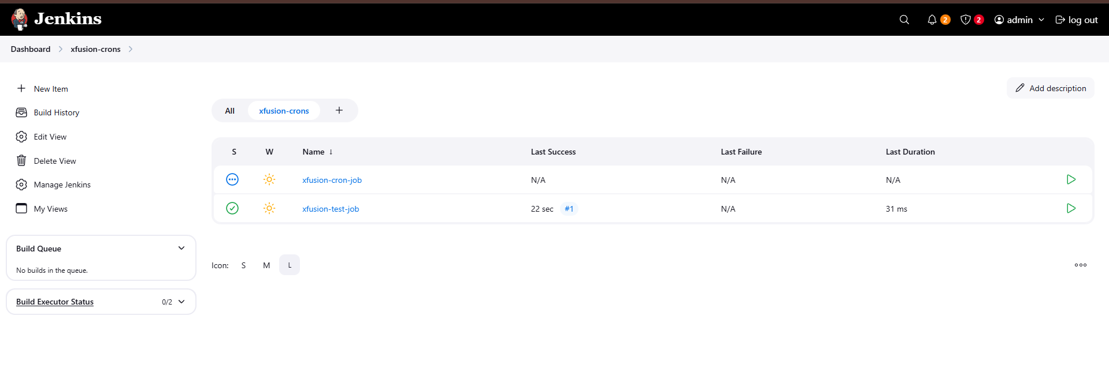

Step 8 — Verify Job Execution
- Wait for one minute or click Build Now.
- Open the job build (#1).
- Check Console Output.
- Confirm that it shows:
- hello world!!
Finished: SUCCESS
